**Phase – II**

**Practice Project – I**

**Validation of the User Login**

**Sai Krishna Rajagopal**

**16-03-2022**

Output:

Login:

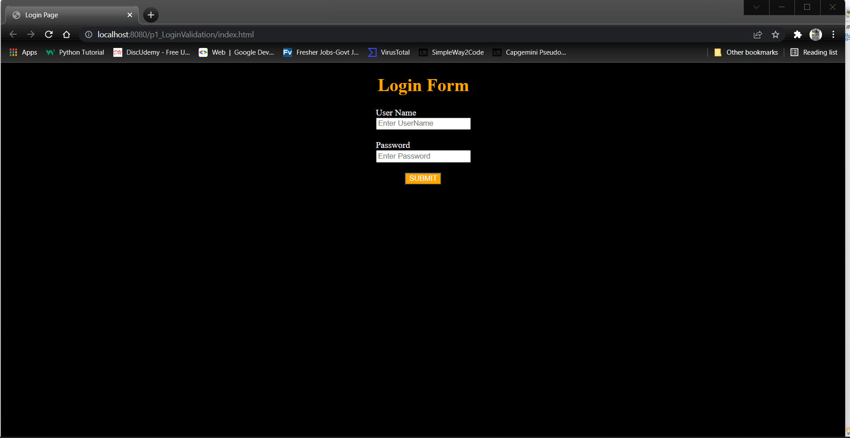

Invalid Login:

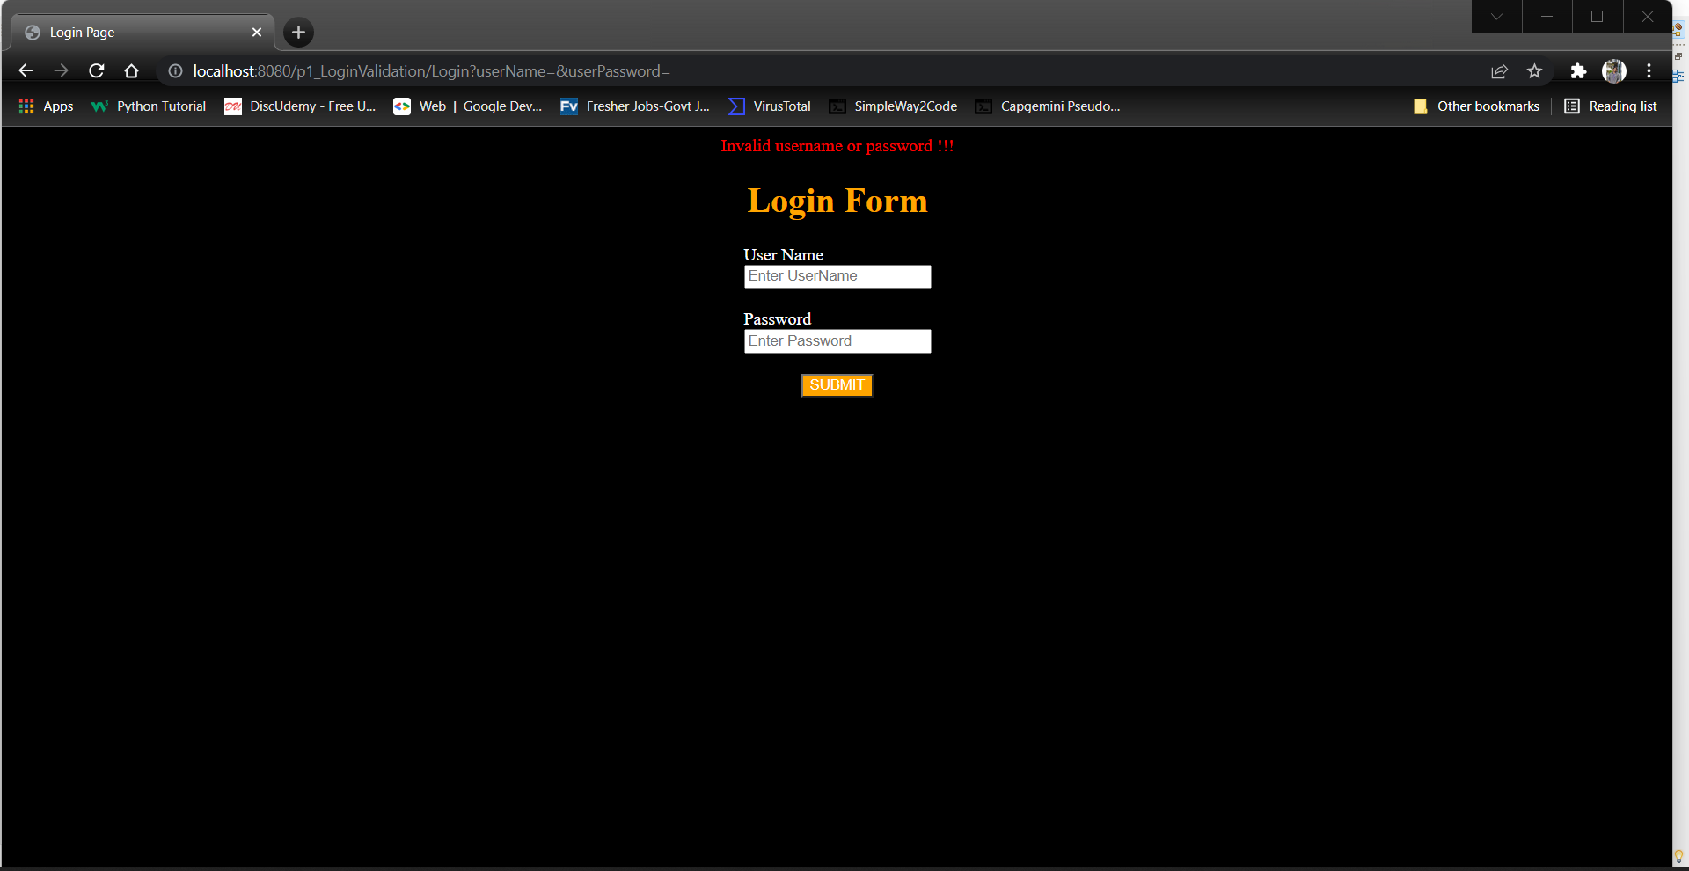

Dash board: After Login:

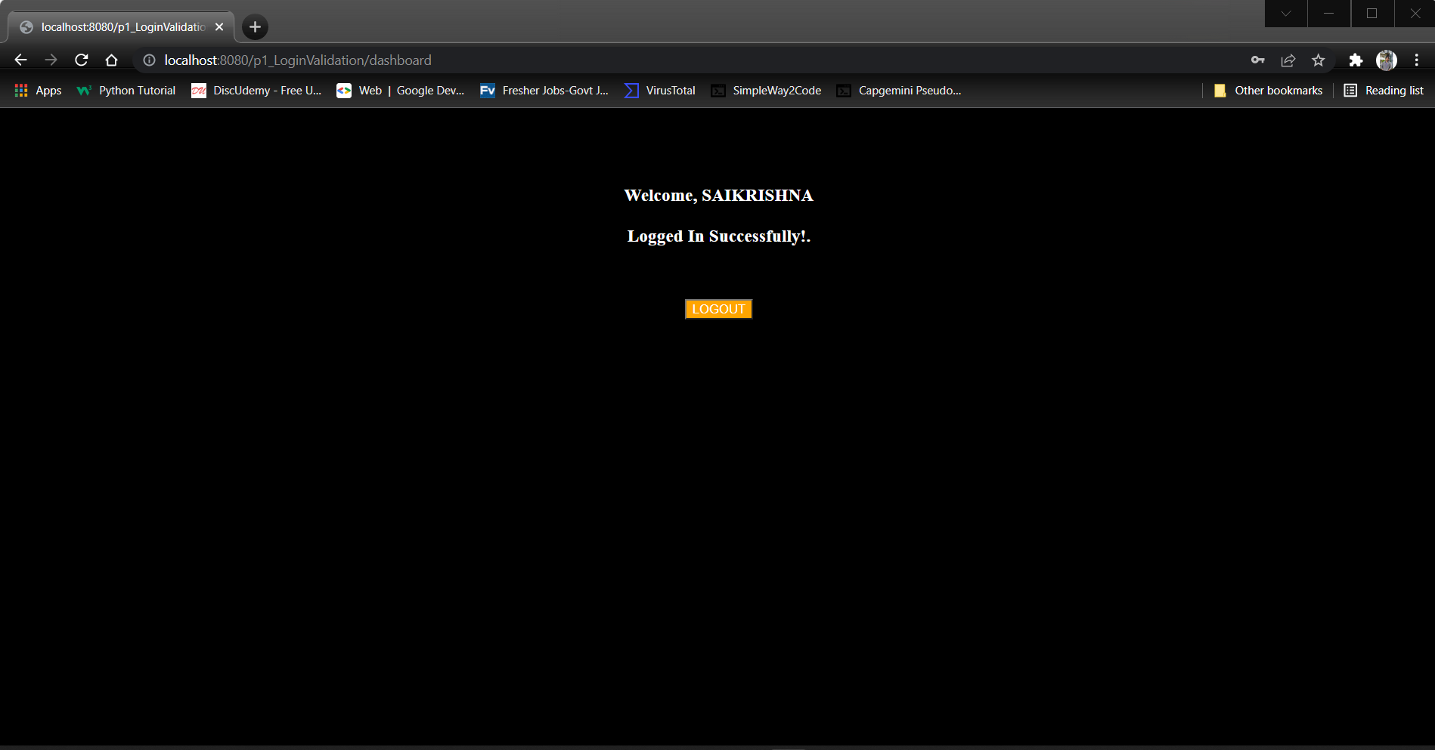

Logout:

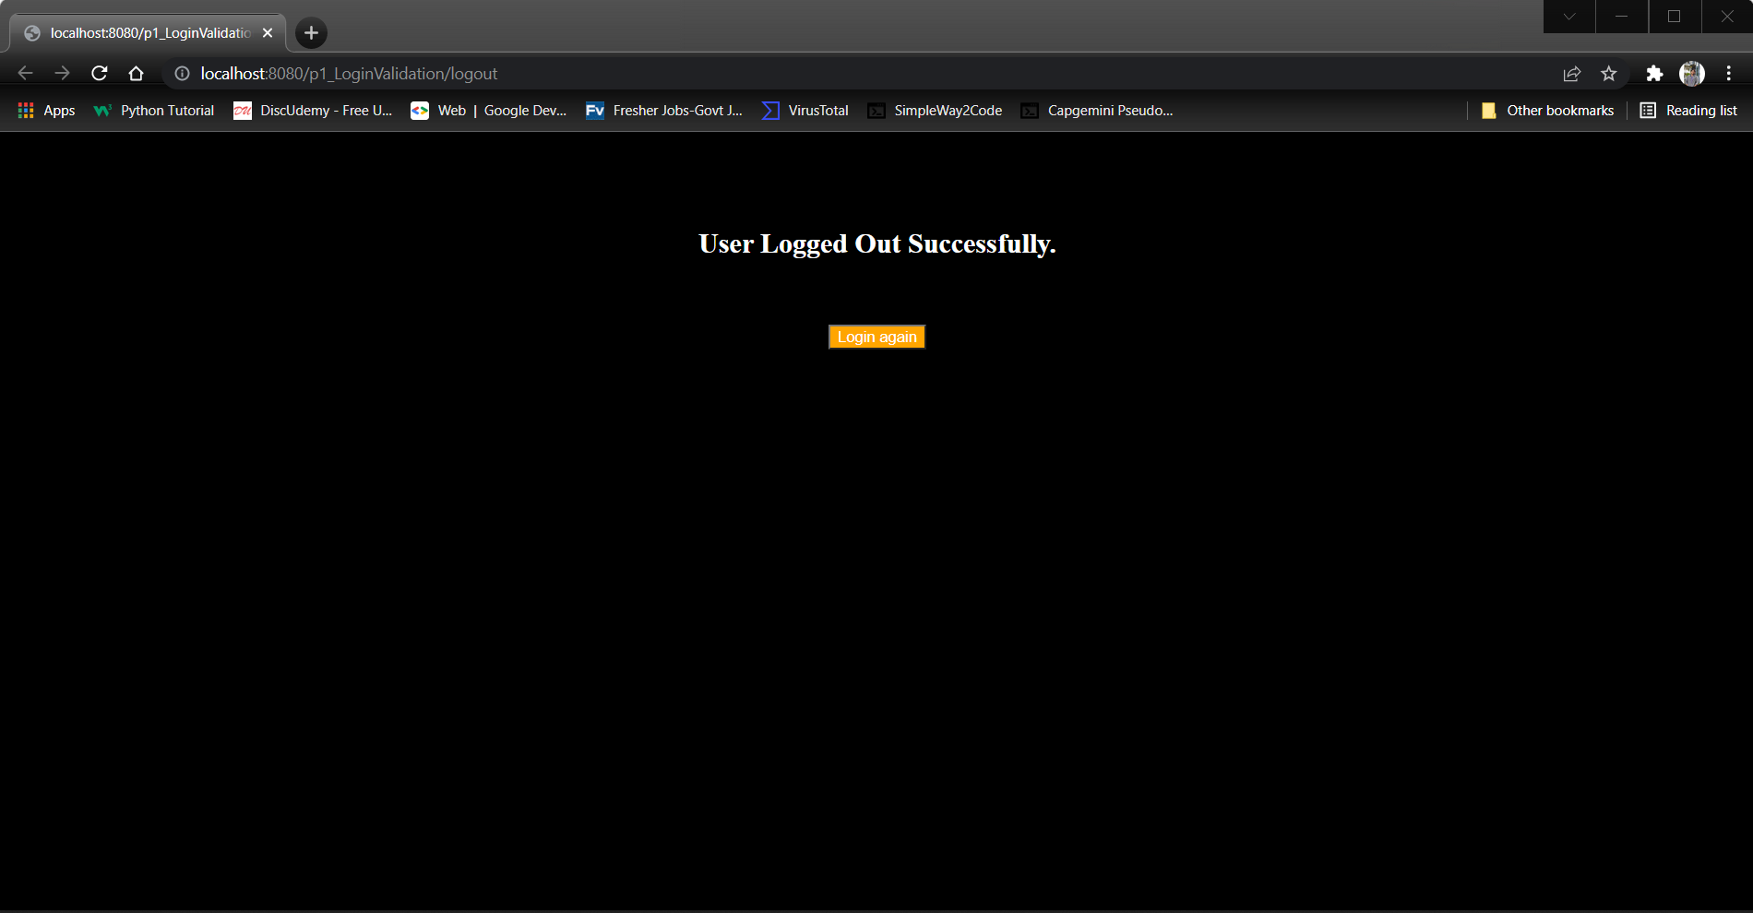

Git:

